THE STORY OF AINO
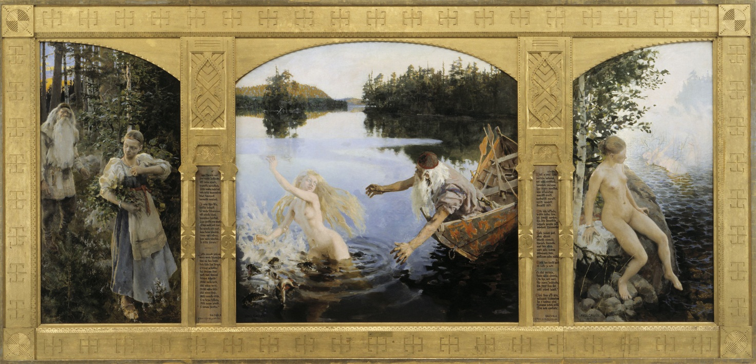

Kalevala is Finland´s national epic and it’s one of the most significant works of Finnish literature. Kalevala includes many stories and here is one of them.
Joukahainen is a young man who envies Väinämöinen´s singing skills and wisdom. He has a sister which name is Aino.
Väinämöinen is known as Väinö “steady old Väinämöinen, the everlasting singer” and “the eternal wise”. He is also leading figure of the epic, appearing in the most of the poems of the Kalevala.

Joukahainen and Väinämöinen started to fight about which one is smarter. They argued and finally Väinämöinen sings Joukahainen into a swamp. Joukahainen started to sink. He was so afraid that he promised his sister Aino would marry Väinämöinen. Väinämöinen accept the offer and let him out of the swamp. He regret that he had promised his sister to old Väinämöinen. Joukahainen returned back to home crying. He explained whole story to his mother. She was so happy because she had always wanted a rich and famous husband to her daughter. She started to sing. When Aino heard her mother´s song she started to cry. Aino didn´t want to marry old Väinämöinen. Her mother tried to comfort Aino. She cried many days and finally she decided to take her own life. She put beautiful clothes on and went to the beach. She sat on the beach and cried all night. In the morning she saw mermaids on the water. Aino swam to the mermaids and disappeared under the waves. She rather drown than marry Väinämöinen.

